Order fulfillment

Description
BPMN 2.0 by Example (Order Fulfillment and Procurement) with rewording and explicit modeling of customer and wholesale shop. Last two tasks of happy path are paralellized because generally there is no specific order required.
Source: OMG: BPMN 2.0 by Example, June 2010 (p. 5)

Model
BPMN Diagram types: Process,
Source files: orderfulfillment.sgx, orderfulfillment.bpmn orderfulfillment-all.pdf
Diagram files: , orderfulfillment.pdf
orderfulfillment.svg
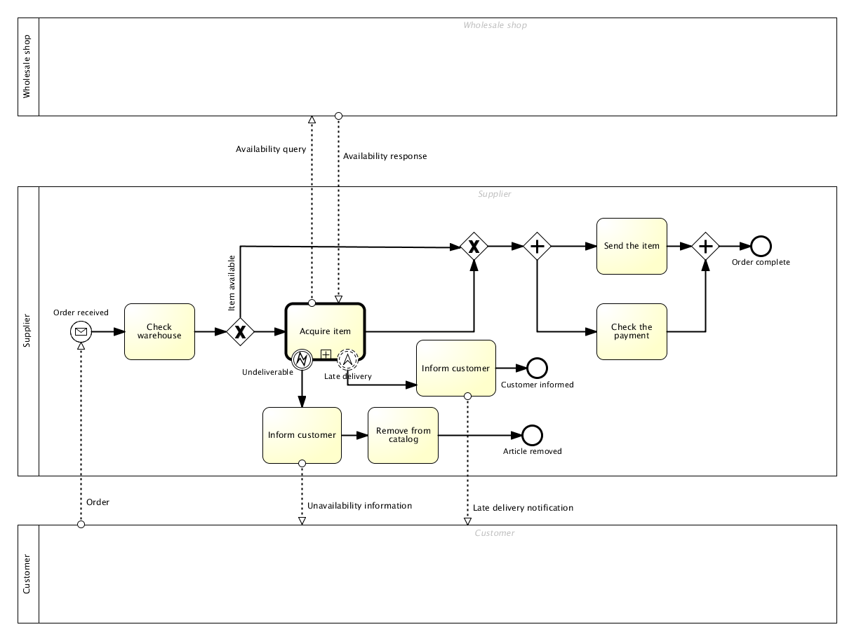Orderfulfillment Bimloq case BPMN model

Subprocesses
L.p. | Name | Model
1 | Acquire item | pub:projects:bimloq:cases_bimloq:bimloq_case_orderfulfillment:orderfulfillment-1.png

Acquire item
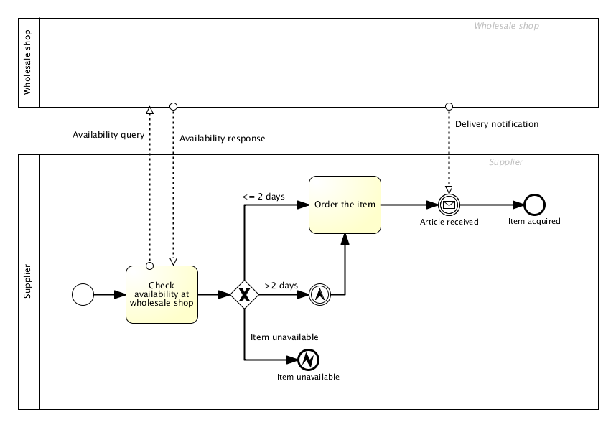

Model logic

Model metrics
Main process:
Abbreviation | Name | Value
CNC | Coefficient of Network Complexity | 1.45
IC | Interface Complexity Metric | 63.0
NOA | Number of Activities in a Process Metric | 7.0
NOAC | Number of Activities and Control Flow Elements in a Process Metric | 17.0
NOAJS | Number of Activities, Joins and Splits in a Process Metric | 11.0
DSM | Durfee Square Metric | 3.0
PSM | Perfect Square Metric | 5.0
ALL | All Elements | 43.0
Acquire item:
Abbreviation | Name | Value
CNC | Coefficient of Network Complexity | 2.67
IC | Interface Complexity Metric | 8.0
NOA | Number of Activities in a Process Metric | 2.0
NOAC | Number of Activities and Control Flow Elements in a Process Metric | 7.0
NOAJS | Number of Activities, Joins and Splits in a Process Metric | 3.0
DSM | Durfee Square Metric | 2.0
PSM | Perfect Square Metric | 3.0
ALL | All Elements | 22.0

