Credit Card

Description
In the Credit Card case study scenario a process of an application for a credit card is described. When a customer sends a completed application to the bank, the credit card release procedure is started. At the beginning, the application form is received and registered by the system. Then, a credit rating calculation takes place to determine the possible credit card limit. The next stage of the process is verification using various databases. Positive verification means that the credit card type should be determined and the message about the granted credit card should be sent to the customer. If the customer has low credit rating or the verification is negative, the customer should receive refusal information.
Source: Nalepa, G.J., Kluza, K., Ernst, S.: Modeling and Analysis of Business Processes with Business Rules. In: Business Process Modeling: Software Engineering, Analysis and Applications. New York, Nova Science Publishers, pp. 135–156 (2011)

Model
BPMN Diagram types: Process,
Source files: creditcard.sgx, creditcard.bpmn creditcard-all.pdf
Diagram files: , creditcard.pdf
creditcard.svg
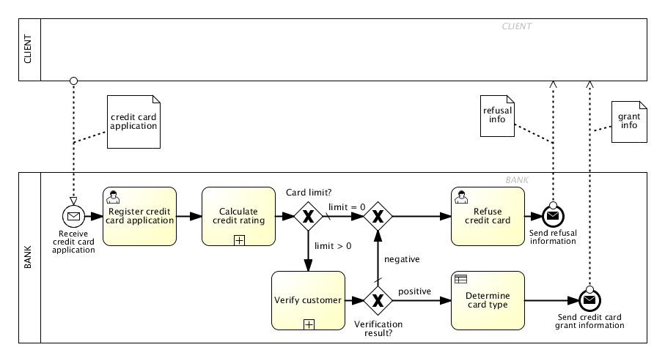Creditcard Bimloq case BPMN model

Subprocesses
L.p. | Name | Model
1 | Calculate credit rating | prv:projects:bimloq:cases_bimloq:bimloq_case_creditcard:creditcard-1.png
2 | Verify customer | prv:projects:bimloq:cases_bimloq:bimloq_case_creditcard:creditcard-2.png

Calculate credit rating
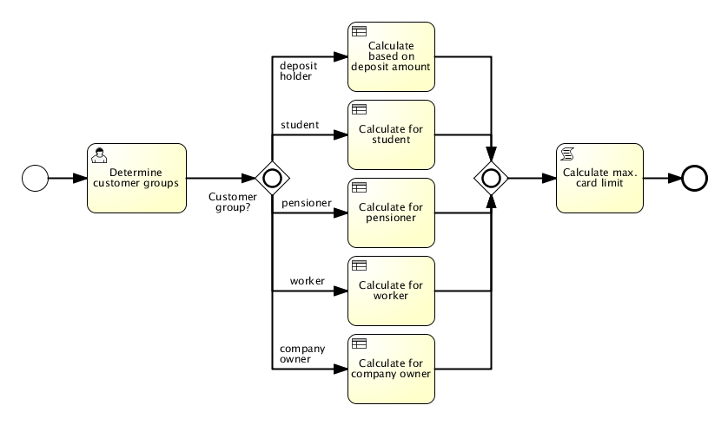

Verify customer
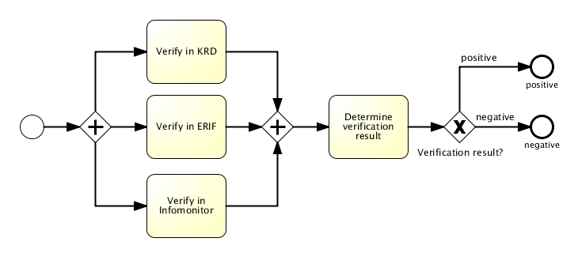

Model logic

Model metrics
Main process:
Abbreviation | Name | Value
CNC | Coefficient of Network Complexity | 1.38
IC | Interface Complexity Metric | 20.0
NOA | Number of Activities in a Process Metric | 5.0
NOAC | Number of Activities and Control Flow Elements in a Process Metric | 11.0
NOAJS | Number of Activities, Joins and Splits in a Process Metric | 8.0
DSM | Durfee Square Metric | 3.0
PSM | Perfect Square Metric | 4.0
ALL | All Elements | 28.0
Calculate credit rating:
Abbreviation | Name | Value
CNC | Coefficient of Network Complexity | 1.56
IC | Interface Complexity Metric | 7.0
NOA | Number of Activities in a Process Metric | 6.0
NOAC | Number of Activities and Control Flow Elements in a Process Metric | 10.0
NOAJS | Number of Activities, Joins and Splits in a Process Metric | 8.0
DSM | Durfee Square Metric | 2.0
PSM | Perfect Square Metric | 4.0
ALL | All Elements | 24.0
Verify customer:
Abbreviation | Name | Value
CNC | Coefficient of Network Complexity | 1.57
IC | Interface Complexity Metric | 16.0
NOA | Number of Activities in a Process Metric | 4.0
NOAC | Number of Activities and Control Flow Elements in a Process Metric | 10.0
NOAJS | Number of Activities, Joins and Splits in a Process Metric | 7.0
DSM | Durfee Square Metric | 2.0
PSM | Perfect Square Metric | 4.0
ALL | All Elements | 21.0

