Ambient Intelligence Laboratory

Equipment
- 16 laptop computers
- 2 android smartphones
- 4 android tablets
- 1 (so far) pair of augmented reality glasses
- 1 smartboard

Idea
Ubiquitous computing recently gain a huge popularity in a field of artificial intelligence. Tablets, smartphones, and in a near future - augmented reality glasses - all of these are omnipresent in human daily life. Mobile devices became more user friendly, but at the same time more “programmer-friendly” and computationally powerful. All of this makes them perfect tools for researchers and engineers.
The Ambient Intelligent Laboratory was built to
- exploit possibilities of modern mobile devices in artificial intelligence,
- give students and researchers chance to be up-to-date with scientific and technical trends,
- provide a place and tools for students and researchers that will allow for advancements in both professional and scientific skills
- make science more ambient and ubiquitous

Old times

Labs and equipment
At the team disposal are two modern computer labs. In the labs a heterogeneous networking environment is provided with both GNU/Linux as well as other environments.
In 2008 a new robotics lab (Mobile Robots Laboratory) has been created. It is equipped with 12 LEGO Mindstorms NXT robotic sets and two mobile robots Hexor by Stenzel. The lab is being used to teach basics of intelligent robots control.
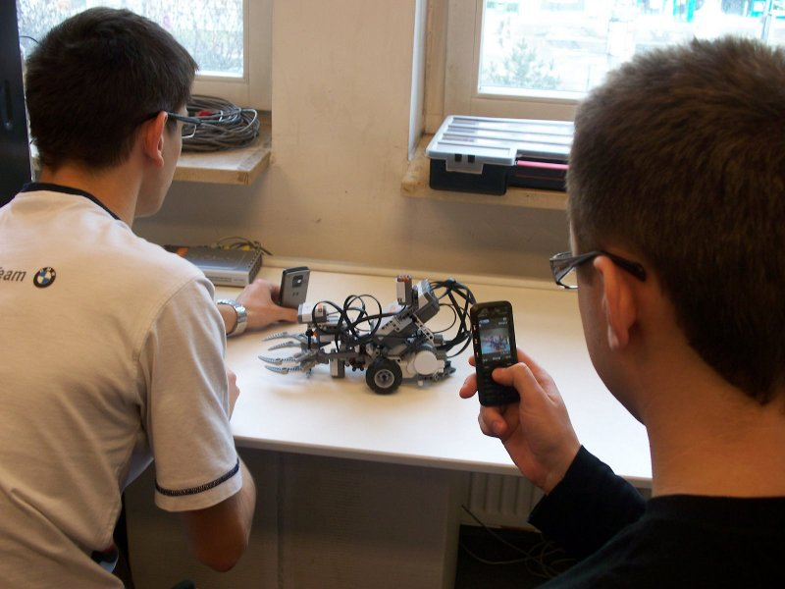Array
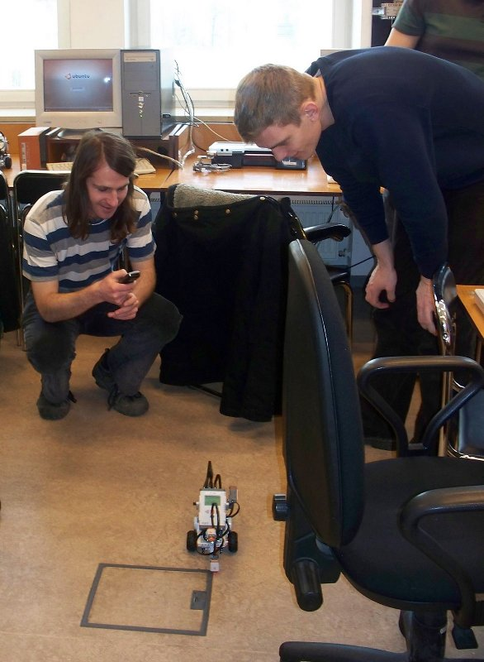Array
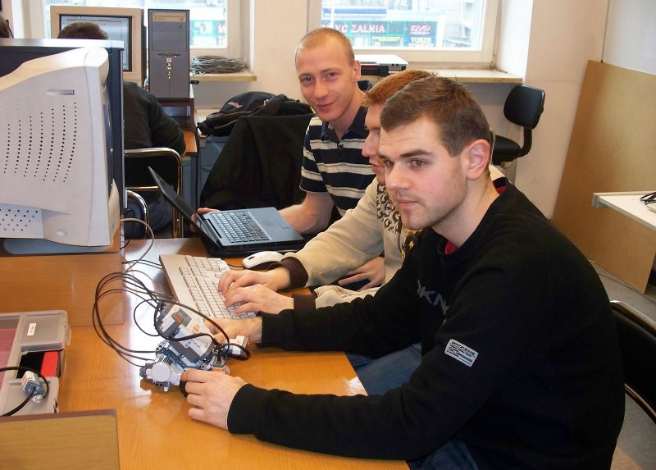Array
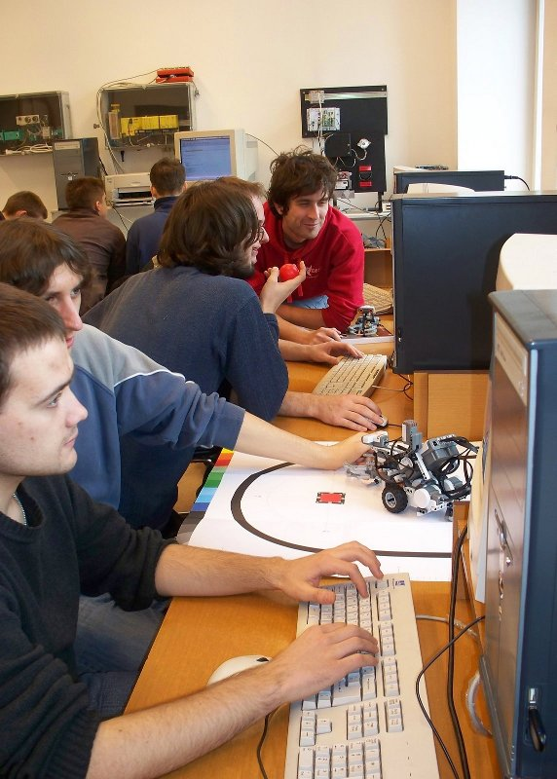Array
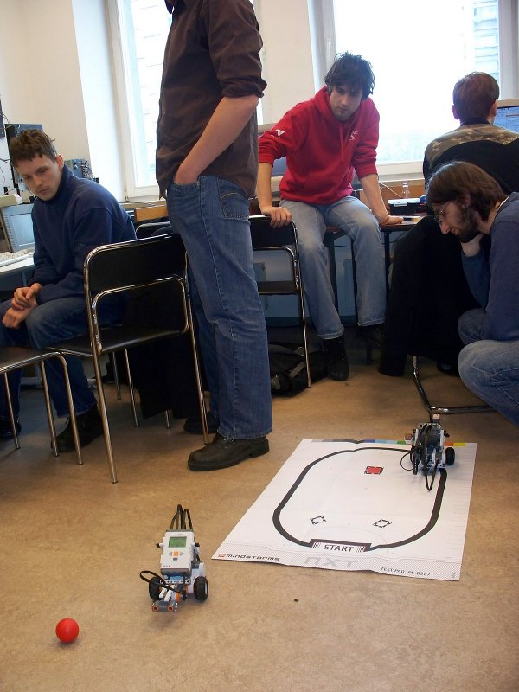Array

