About GEIST  - People  - News  - Contact  - Teaching | Our Research  - Profile  - Projects  - Development  - Publications  - Software | See our projects!  AfCAI  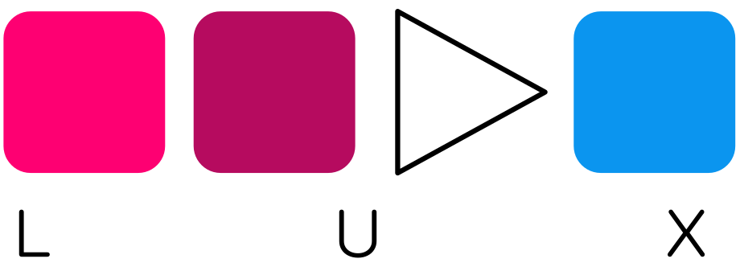LUX  Loki  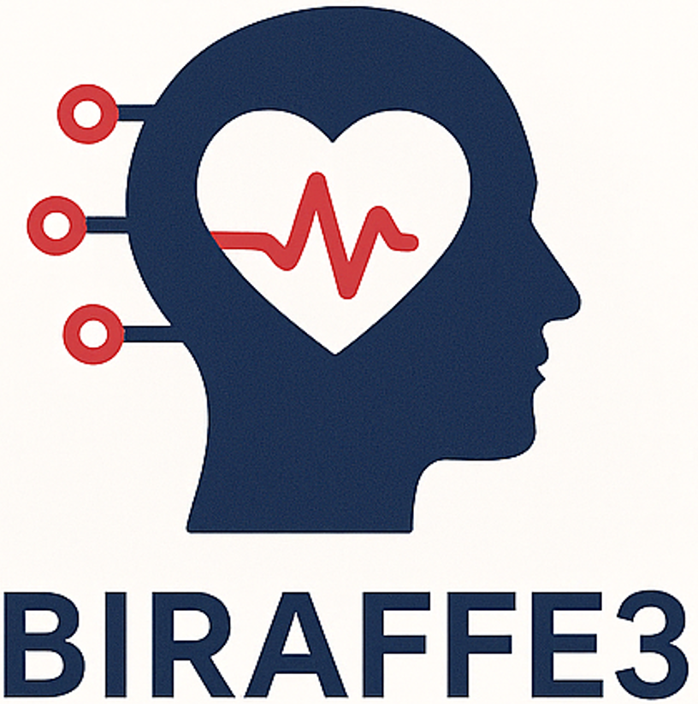BIRAFFE3  GEIST People  Senior Associated Researchers, Full Professors | Grzegorz J. Nalepa  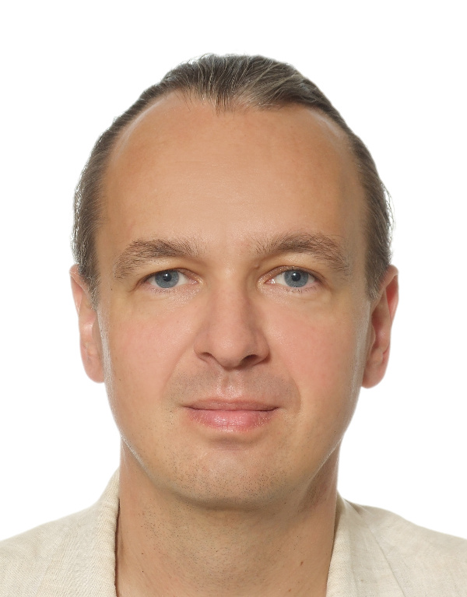  gjn@gjn.re  GJN.re  short bio | Marcin Szpyrka  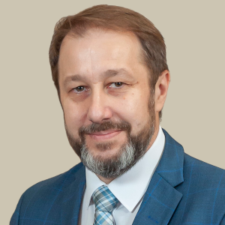  mail  WWW  short bio

Assistant Professors
Szymon Bobek  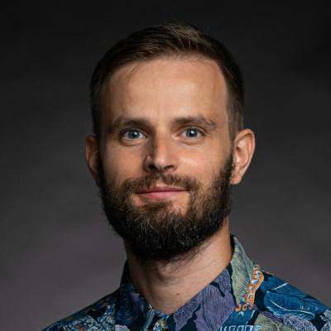  mail  WWW  short bio | Krzysztof Kutt  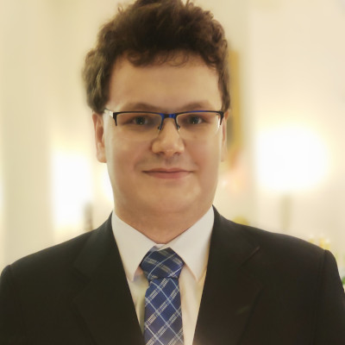  mail  WWW  short bio

PhD Researchers
Jan Ignatowicz  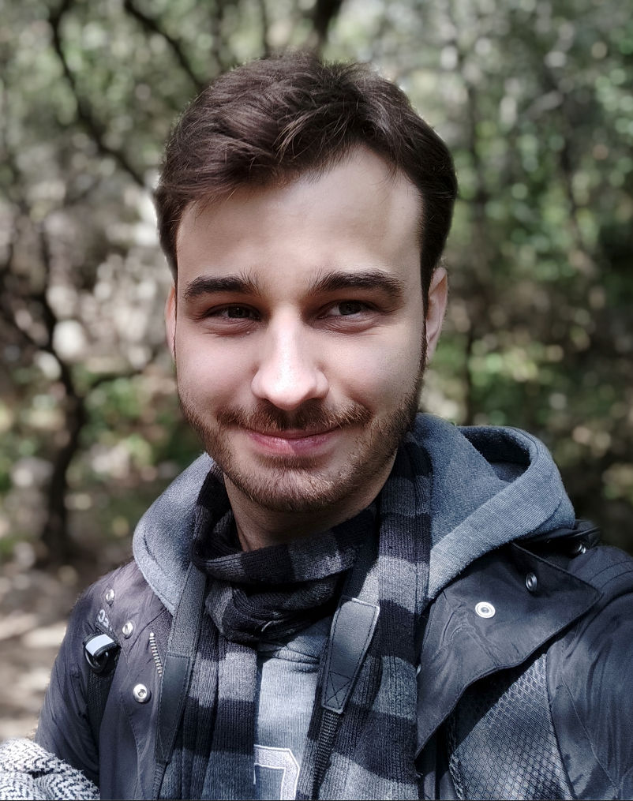  mail  short bio | Jakub Jakubowski  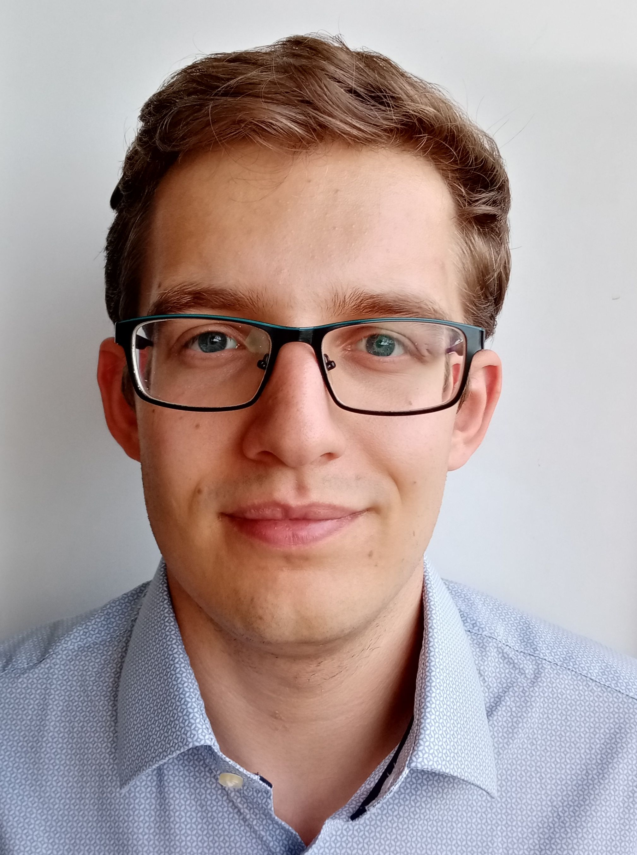  short bio | Michał Kuk  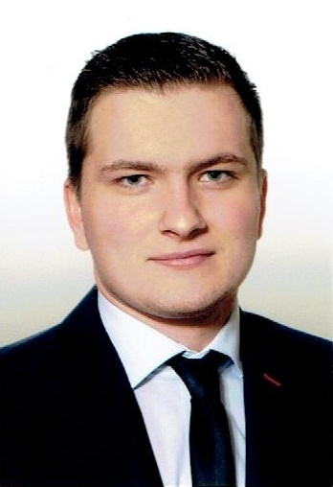  short bio

Bartłomiej Małkus    mail  short bio | Sabri Manai  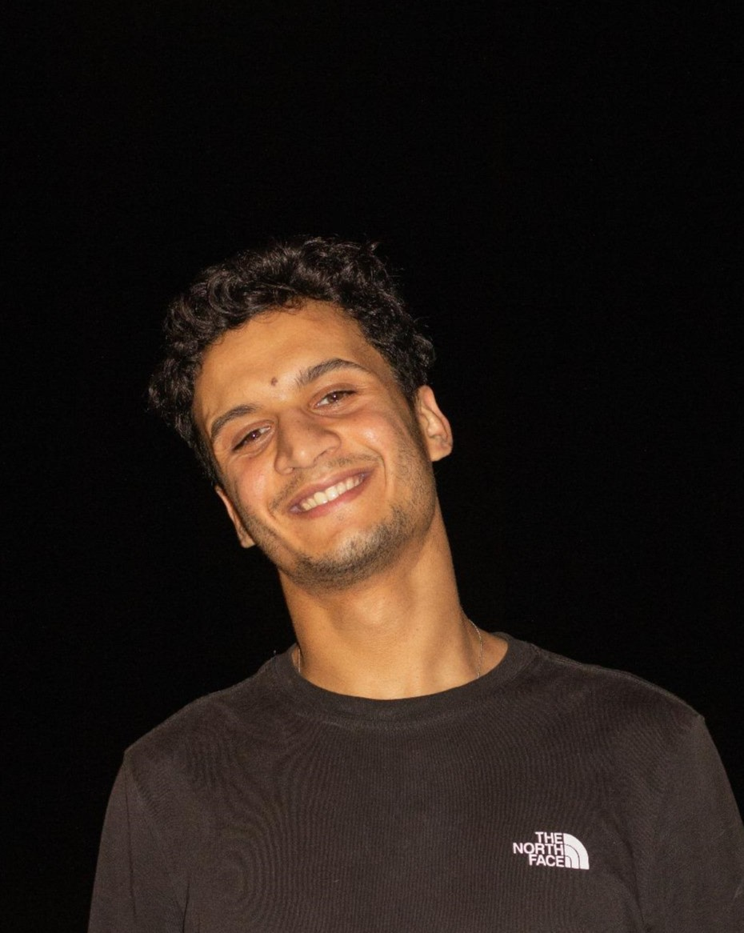  short bio | Luiz do Valle Miranda  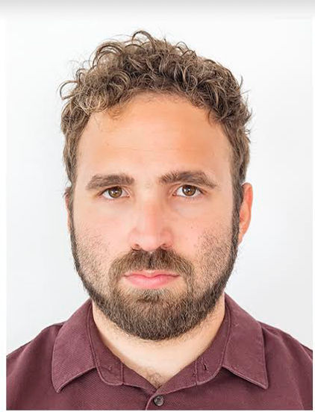  mail  short bio

Maciej Mozolewski  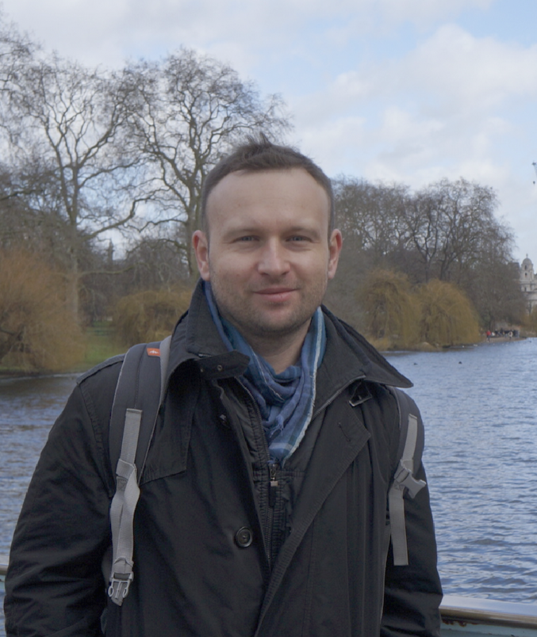  mail  short bio | Maciej Szelążek  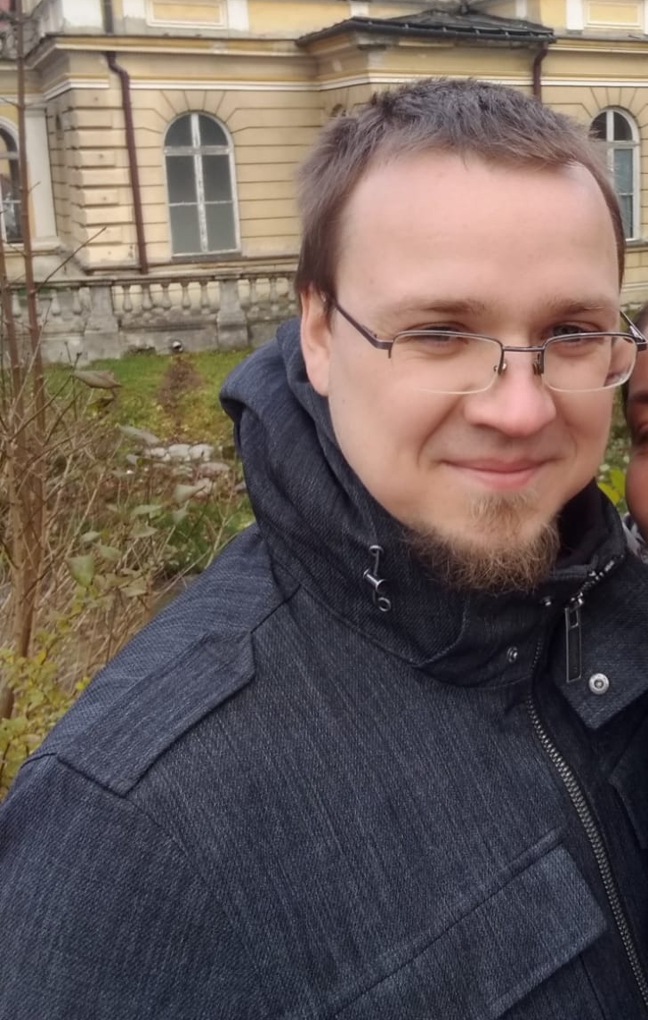  mail  short bio | Natalia Wojak-Strzelecka    mail  short bio

Guests and Interns
Nahuel García-D'Urso  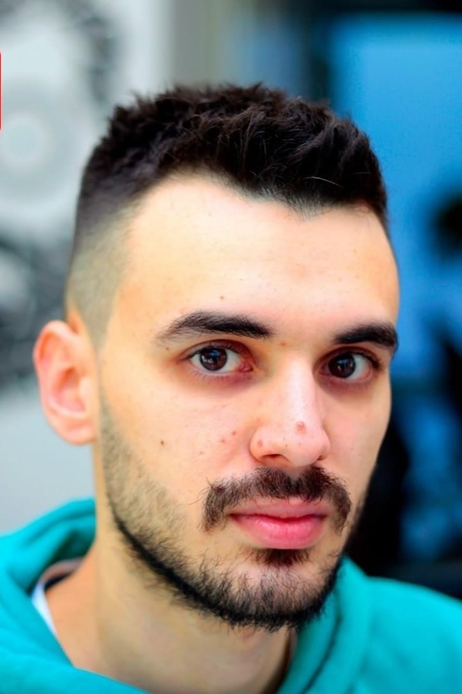  Google Scholar  short bio | Jakub Gomułka  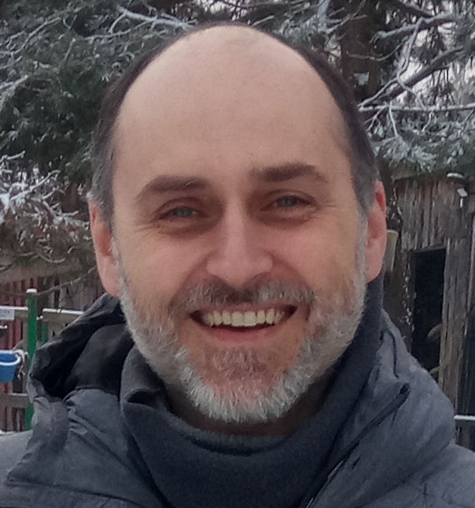  Google Scholar  short bio | Antonio Guillén-Teruel  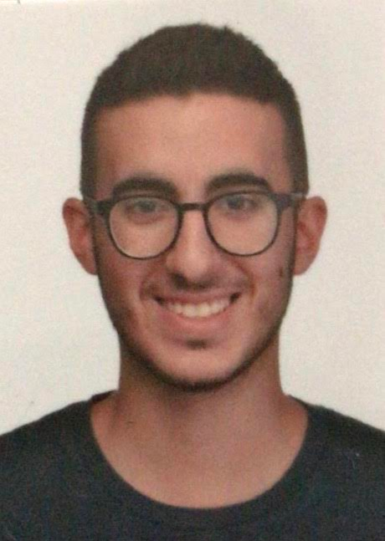  mail  Google Scholar  short bio
Radosław Pałosz  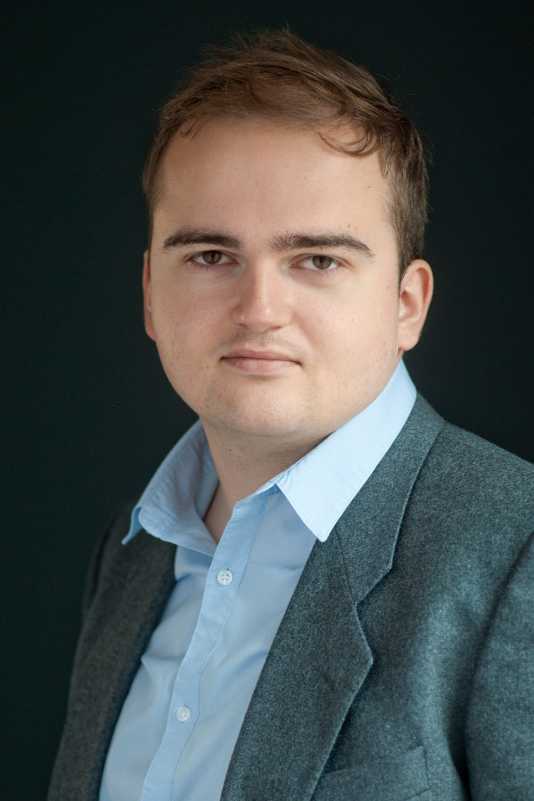  mail  short bio | Víctor Rodríguez Fernández  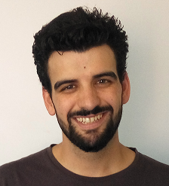  mail  Google Scholar  short bio | Przemysław Stanisz  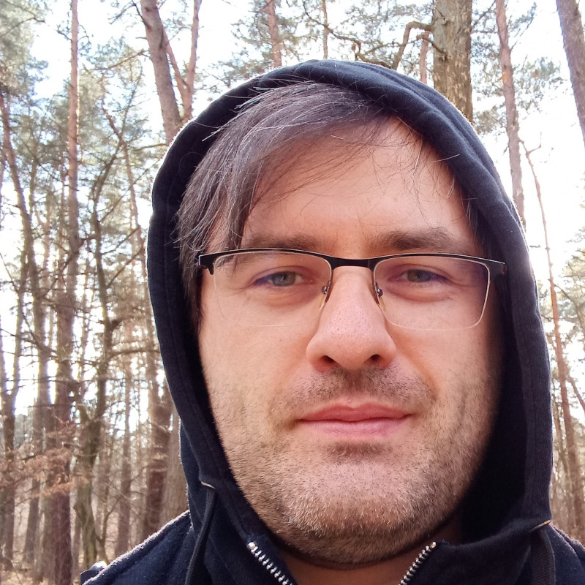  short bio

Hall of Fame: Former/Inactive/Active-Elsewhere Researchers
Antoni Ligęza  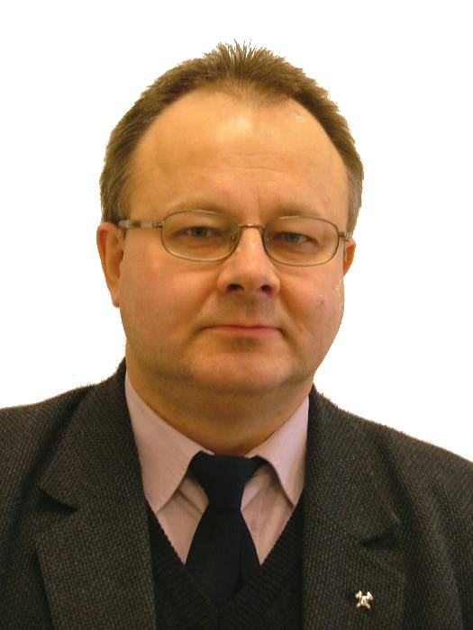  short bio | Sławomir Nowaczyk  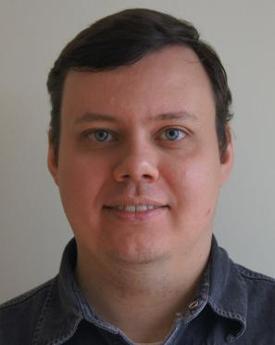  short bio  Now leading lab in Halmstad University, Sweden | Weronika T. Adrian  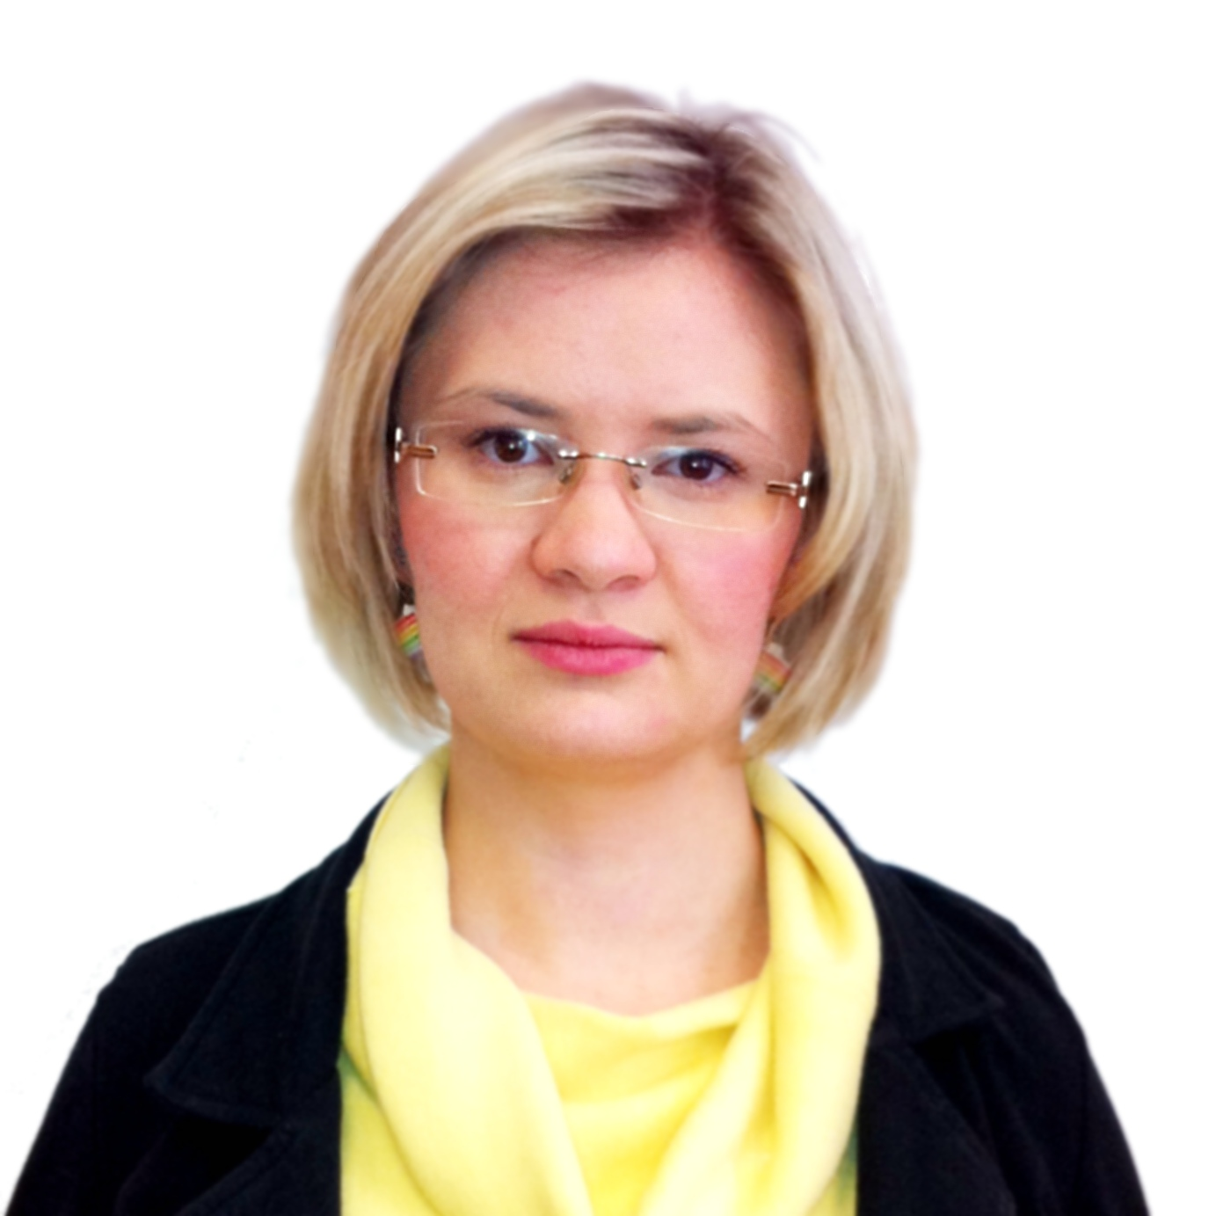  short bio  Now postdoctoral researcher in University of Calabria, Italy

Dominika A. Drążyk    ResearchGate  short bio  Neuro researcher at UCLouvain. | Barbara Giżycka  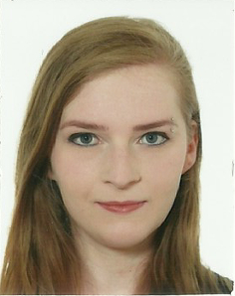  short bio | Paweł Jemioło    short bio

Krzysztof Kaczor    short bio  Gone for the industry. | Krzysztof Kluza    short bio  Lost in the Dean's office | Mateusz Ślażyński    mail  WWW  short bio

Sławomir K. Tadeja  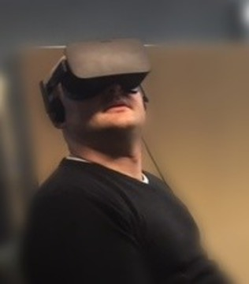  short bio | Michał Wypych    short bio | Michał Zwierzyński  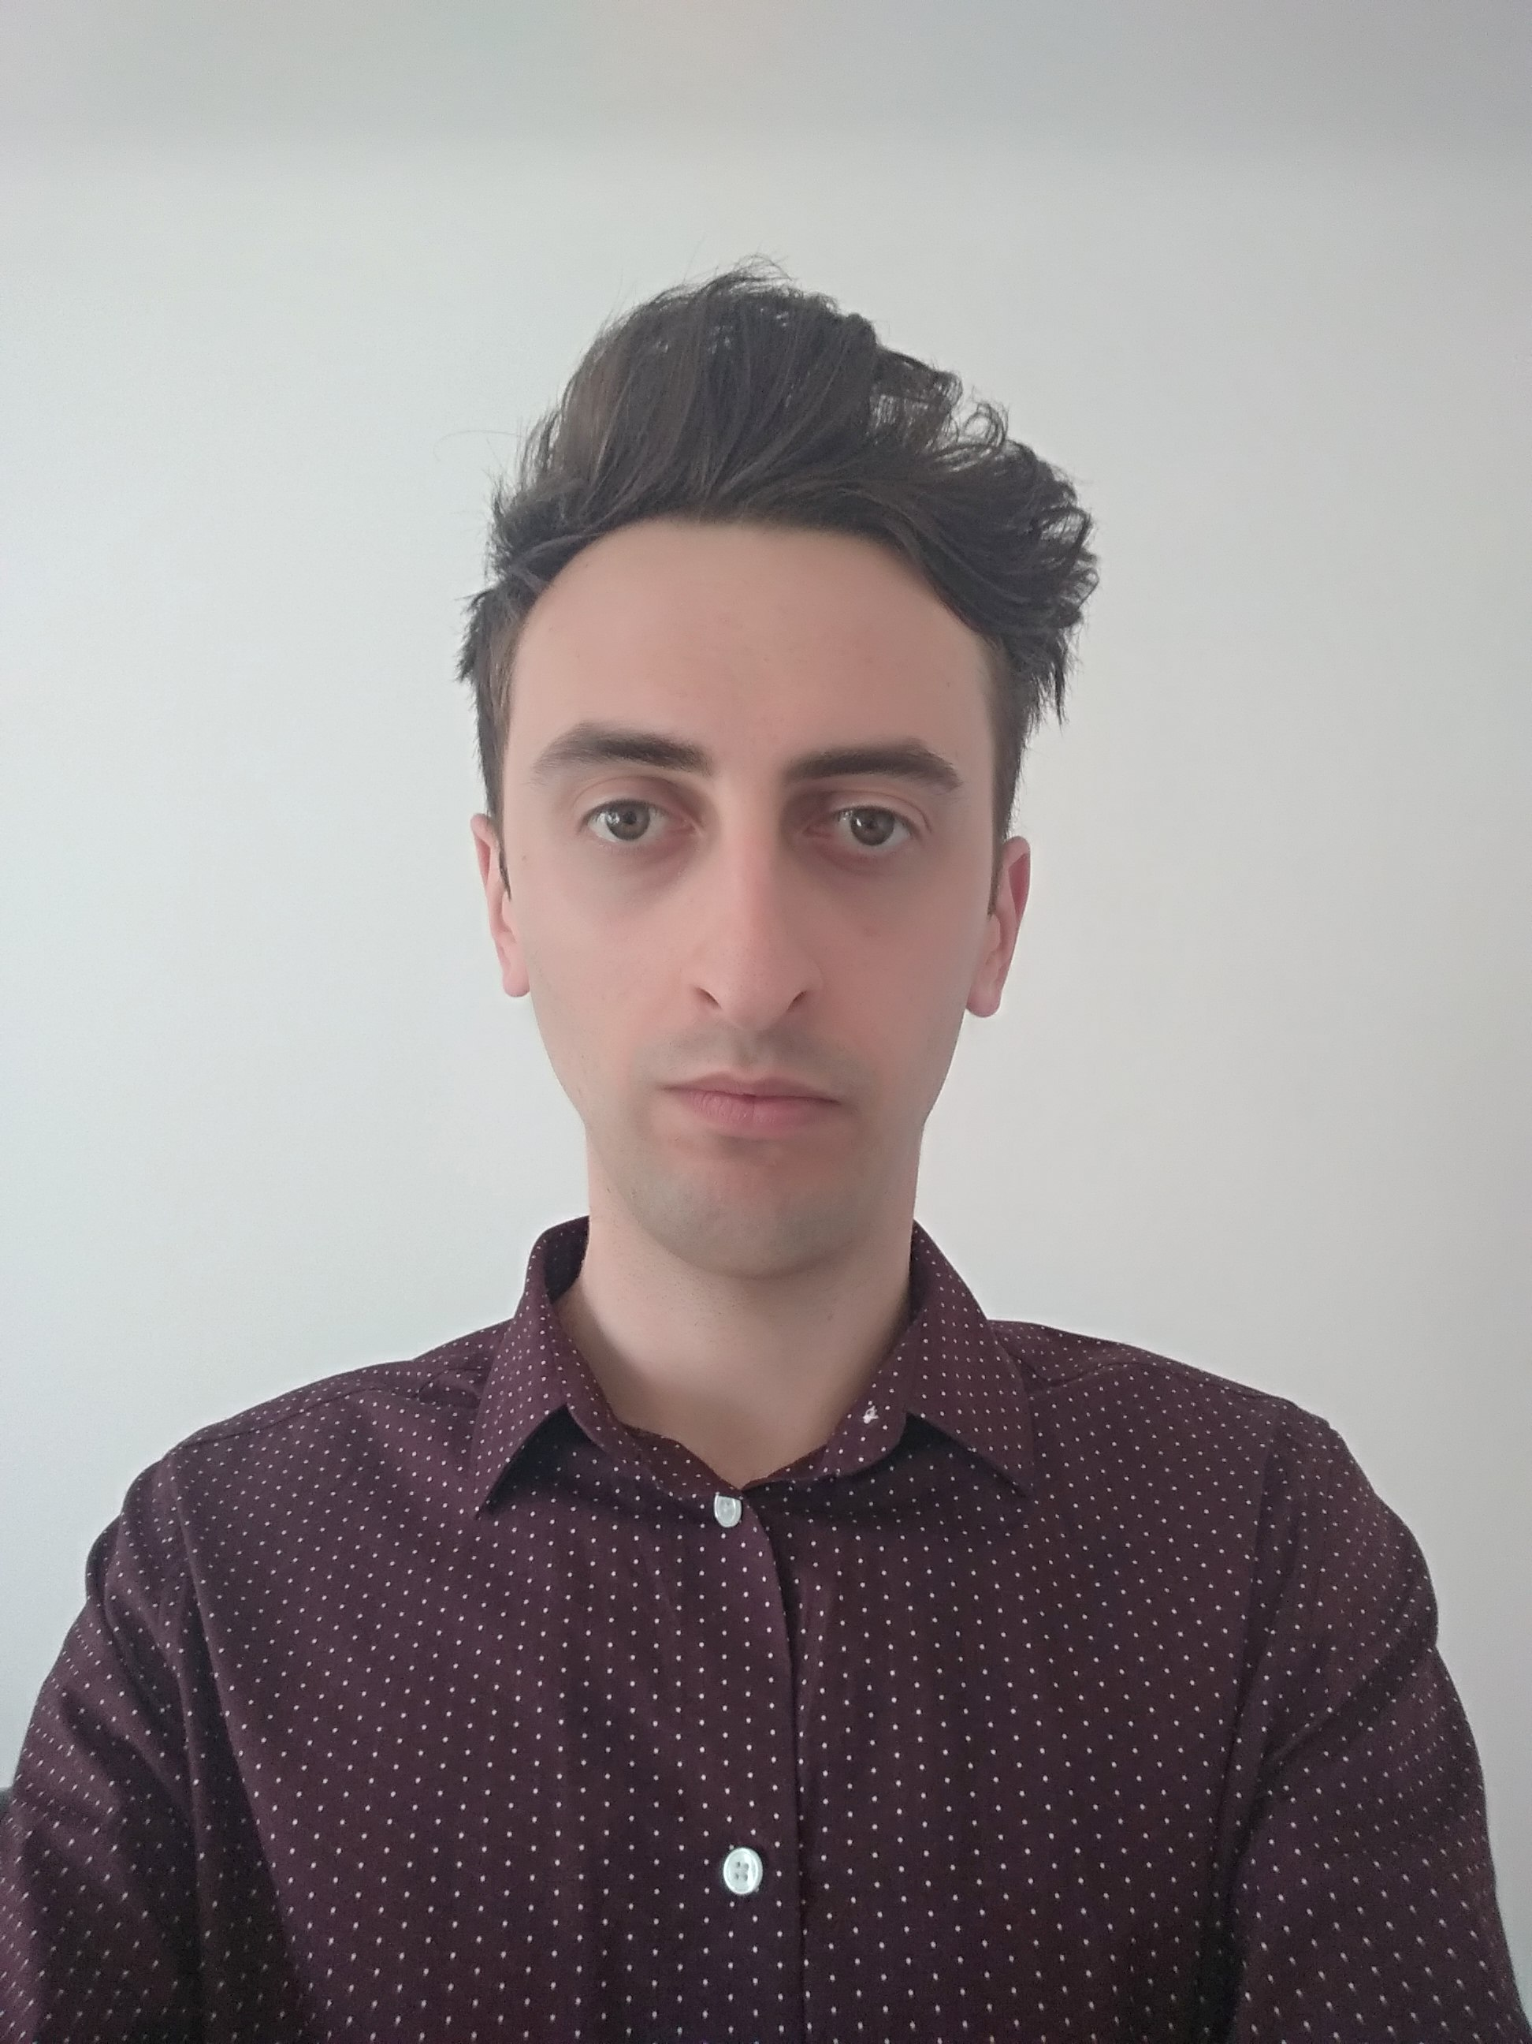  short bio

Honorata Zych
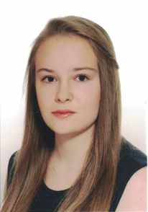
mail
short bio

Selected Former Students
- Olgierd Grodzki
- Rafał Kułaga
- Kacper Łodziński
- Łukasz Łysik
- Radosław O. Milo
- Piotr Misiak
- Laura A. Żuchowska

