Rafała Kułaga
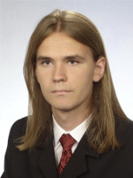Rafała Kułaga
Rafała Kułaga has been involved in GEIST projects since 2010. He has been an active developer for the HQEd editor. His contribution includes redesign of the editor UI. He is actively involved in several open source projects.

