Nahuel García-D'Urso
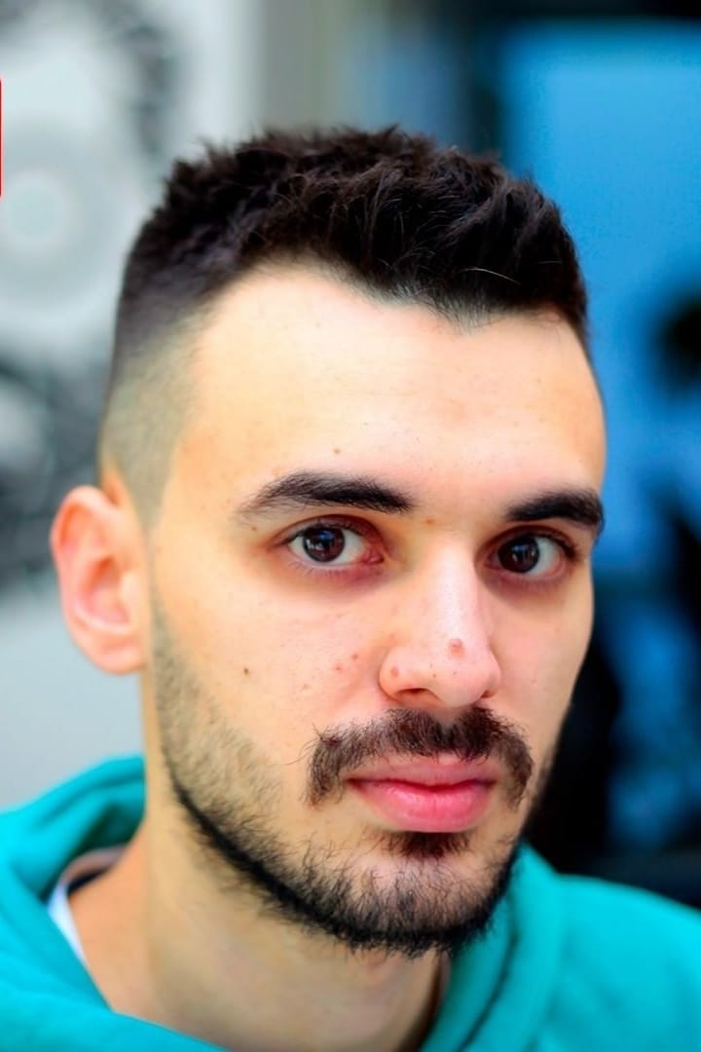Nahuel García-D'Urso
Nahuel García-D'Urso received the bachelor’s and master’s degrees in computer science from University of Alicante, Spain. Currently, he is a last year PhD student at the department of computer technology in the same university, and collaborates in research regarding the Tech4Diet project in a multidisciplinary environment along with nutrition experts of the Faculty of Health Sciences. His research interest lies in machine learning, data science, and computer vision, etc.

More GEIST
→ Meet the whole team.

