Michał Kuk
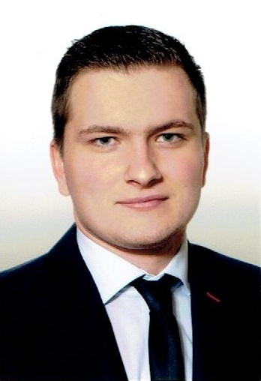Michał Kuk
Michał Kuk MSc. (mkuk@agh.edu.pl) is a graduate of the AGH University of Science and Technology. He graduated from the Drilling, Oil and Gas Faculty in 2017, realizing his master's thesis in which he developed an algorithm optimizing the location of new wells. In 2018, he started Ph.D. studies at the same faculty with a specialization in mining and geology. After graduating from his master's studies, he started working in Gas Transmission Operator GAZ-SYSTEM S.A. where he is responsible for the development of optimization tools dedicated to the company issues. In addition, he works in a team responsible for analyzing data on work safety and creating recommendations to prevent future hazards.

More GEIST
→ Meet the whole team.

