Barbara Giżycka
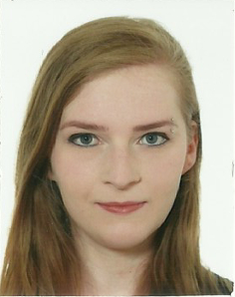Barbara Giżycka
Barbara Giżycka, MSc (bgizycka@agh.edu.pl) is a PhD student at the AGH UST in Krakow, Poland, Department of Applied Computer Science.
She received her MSc degree (2017) and BSc degree (2015) in Cognitive Science at Jagiellonian University. Her fields of interest and research are rooted in affective computing and video game design.
In her free time she likes to read, play video games and explore the Japanese culture.

More GEIST
→ Meet the whole team.

