GEIST news

Events
- 14.04.2011 - GEIST members (Grzegorz J. Nalepa & Krzysztof Kluza) gave a presentation at the Explicite Seminar about the Bimloq research project. The main objectives, current state of work, future plans, as well as possibilities of cooperation have been presented to the audience. Read more...
- 12-13.04.2011 - A photo gallery from the Ontology Workshop in Kazimierz Dolny (see the photos) appeared at the L3G Group Website.
- 31.01.2011 - Read about GEIST in “Nowoczesne standardy w komunikacji elektronicznej” - a short report from the conference in Katowice (read in polish)
- 8.12.2010 - GEIST starts a cooperation with Softhis company in the field of the Semantic Web technologies. Read more...
Softhis-SemanticWeb-ReadMore...
- 2-16.12.2010 - GEIST supports Legomotive Robots Competition organized by BEST
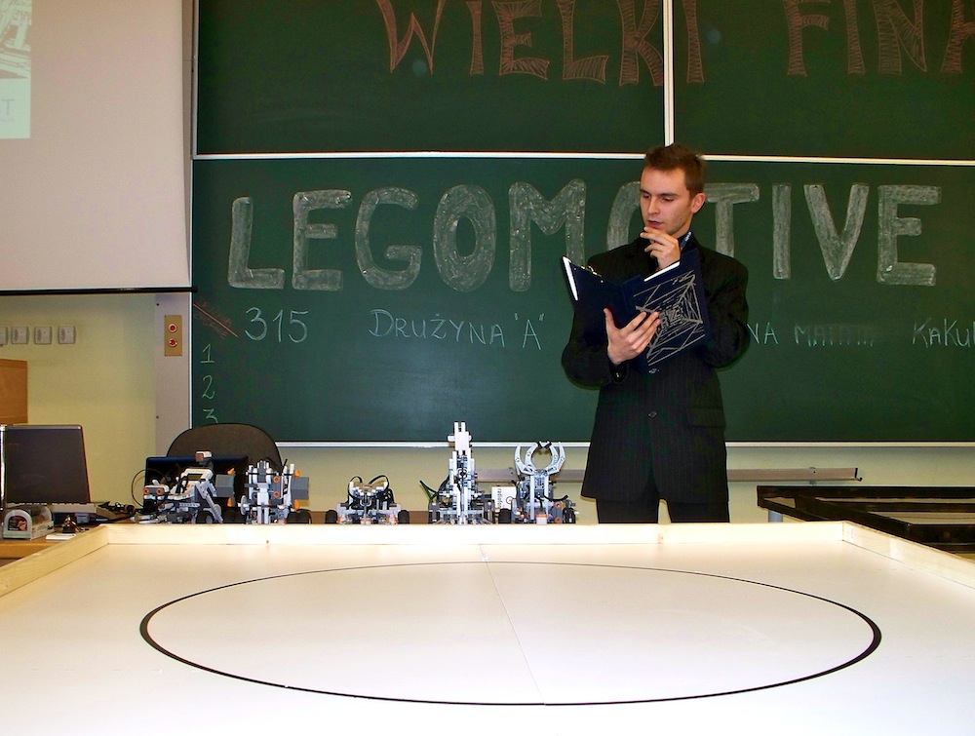Array
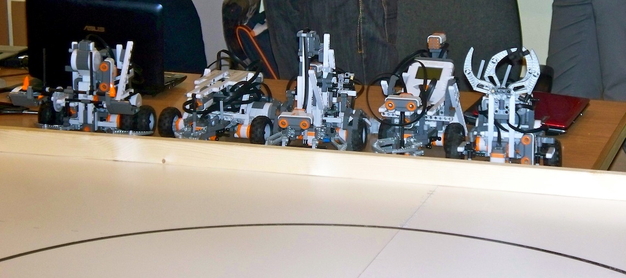Array
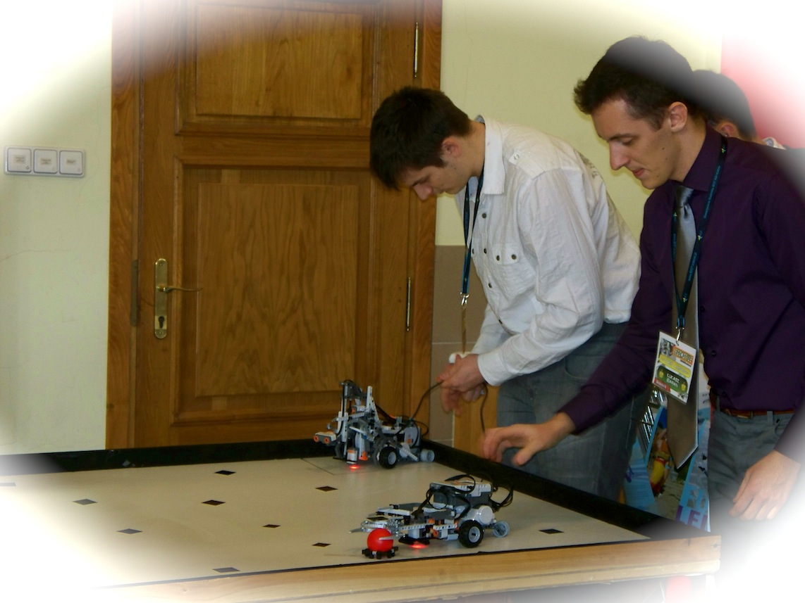Array
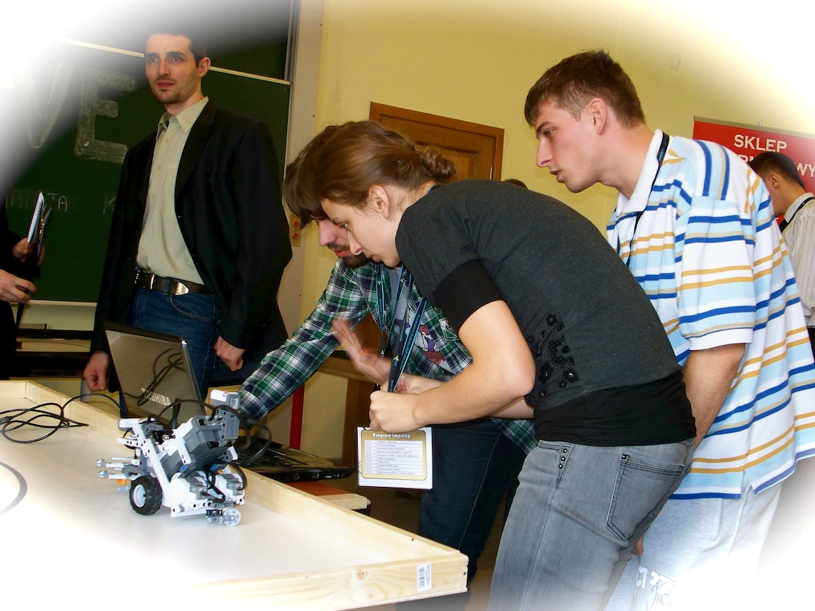Array
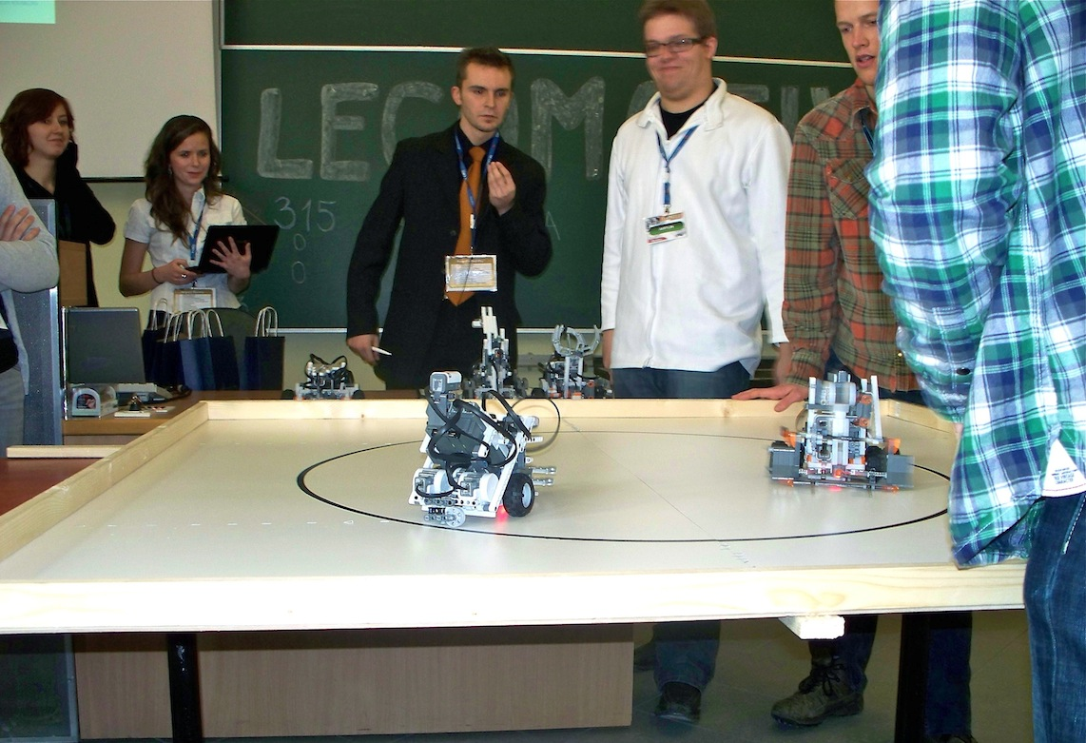Array

Archive
- 2-11.12.2009 - GEIST supports Legomotive Robots Competition organized by BEST
- 20.11.2009 - GEIST is a co-organizer of Global Entrepreneurship Week at AGH
- 19.10.2009 - GEIST prototype wiki goes online
- 8.10.2009 - First Official GEIST Meeting

Conferences
Coming events we are involved in:
—- dataloop —- cols : name, begin_dt, website_url, city, country, participants_geists where : end>%today% and : participants_geists != “” sort : ^begin

- @@begin_dt@@ - Meet GEIST (@@participants@@) at @@name@@?(, @@city@@)??(, @@country@@)?. ?(See @@website@@.)?
—- enddataloop —-

Recent conference activity
We have attended —- dataloop —- cols : name, begin_dt, end_dt, website_url, city, country, participants_geists, conf-name max : 5 where : end ⇐ %today% and : participants_geists != “” sort : ^begin

- @@begin_dt@@ - @@end_dt@@ - @@name@@?( at @@conf-name@@)??(, @@city@@)??(, @@country@@)?. ?(See @@website@@.)?
—- enddataloop —-
→ Read more...

Conference news
—- dataloop —- cols : acronym, name, begin, end_dt, website_url, city, country, conf-name where : begin >= %today% and : public=yes sort : begin

- @@acronym@@: @@name@@?( at @@conf-name@@)??(, @@begin@@)??(, @@city@@)??(, @@country@@)?. ?(See: @@website@@.)?
—- enddataloop —-

